**NAME: GOH FANG YAO**

**MATRIC NO.: 270654**

**Programming 2- Assignment 3**

**Output:**

**Frame 1:**

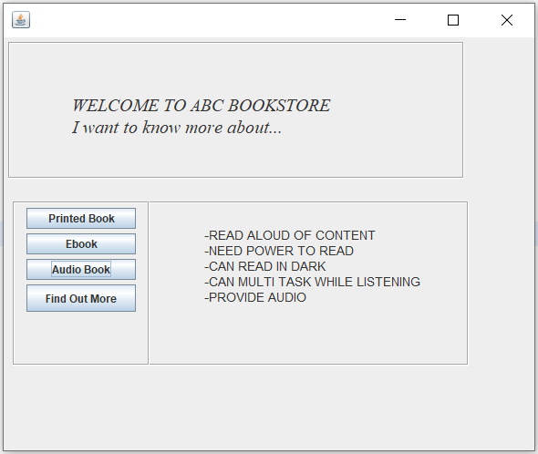

Frame 1 shows us information of type of book and when we click “Find Out More” button, we will go to the next frame which is Frame 2.

**Frame 2:**

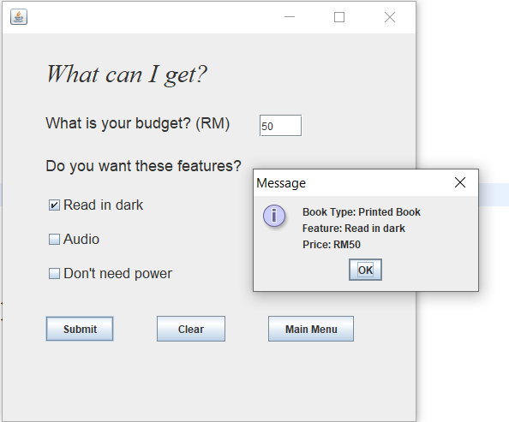

Frame 2 shows us our purchase information and when we click “Main Menu” button, we will go to the Main Menu frame

**Main Menu:**

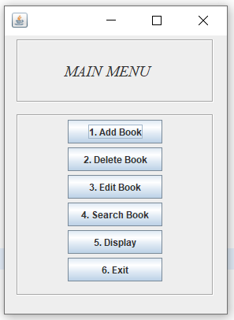

When we click each of the button options, we will go to the frame that we want. And when we click “Exit” button, we will exit from this Main Menu frame.

1. **Add Book**

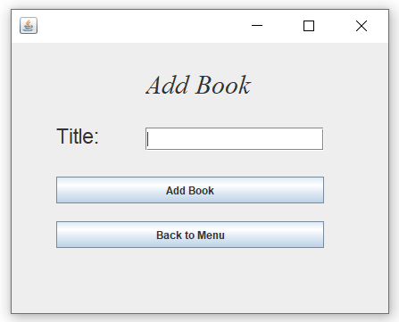

* Key in the book title you want to add and press “Add Book” button to add book to Book.txt file

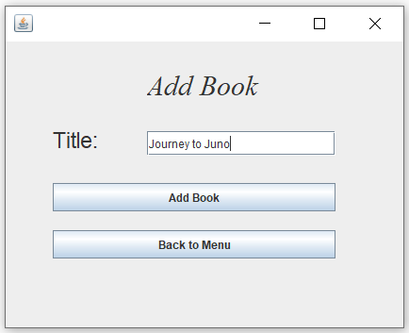

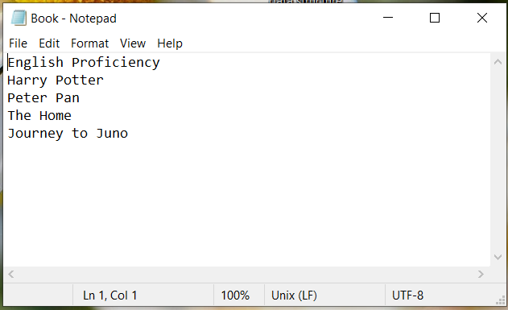

* <<Journey to Juno>> was added to Book.txt file

1. **Delete Book**

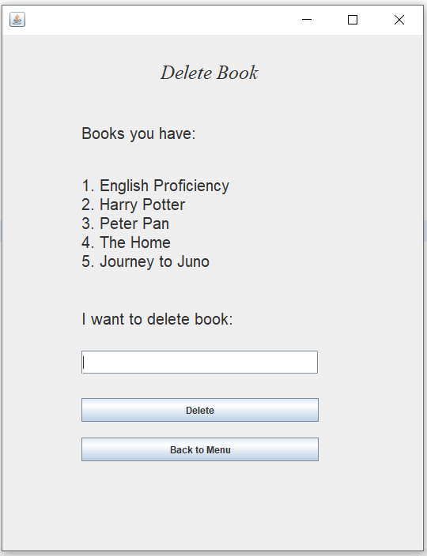

* Now, you have these 5 books in Book.txt file. Key in the numerical number of book you want to delete then press “Delete” button. The book you want to delete will be delete in the book list and Book.txt file

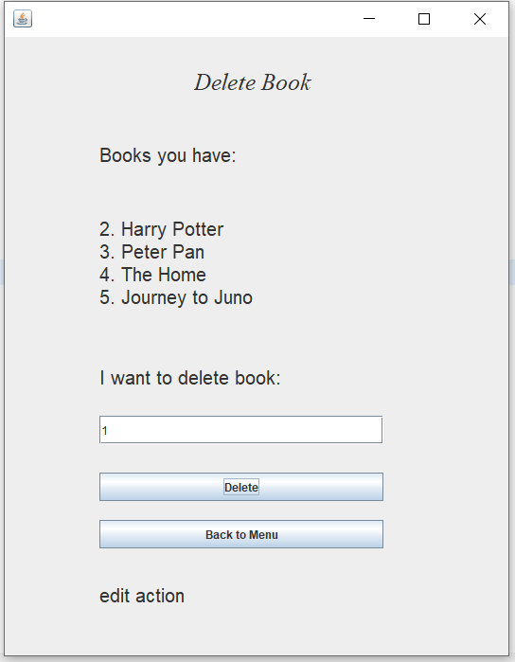

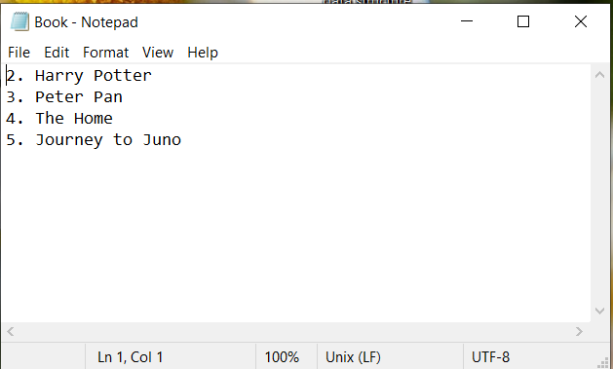

* Book number 1 which is <<English Proficiency>> has been deleted.

1. **Edit Book**

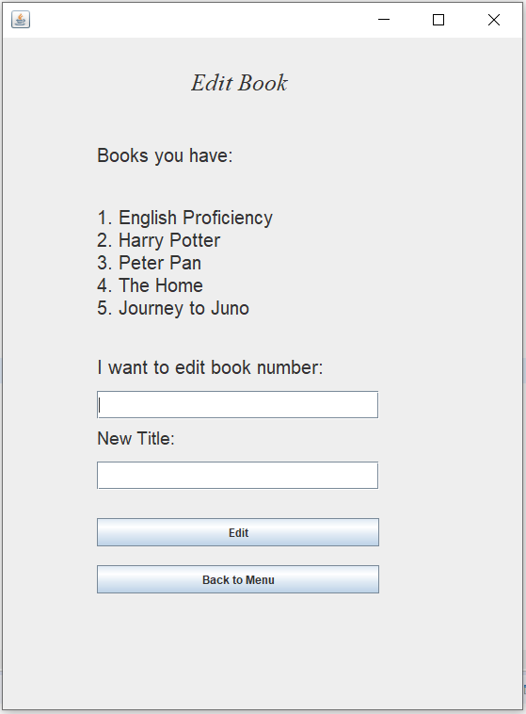

-Now, you have these 5 books in Book.txt file. Enter the numerical number of book you want to edit and type a new title for the book you want to change. After that, press “Edit” button. The book that you edit will be changed in Book.txt file

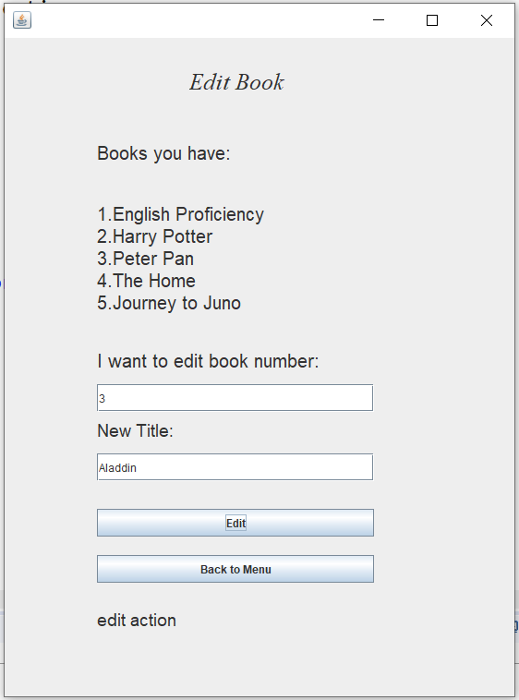

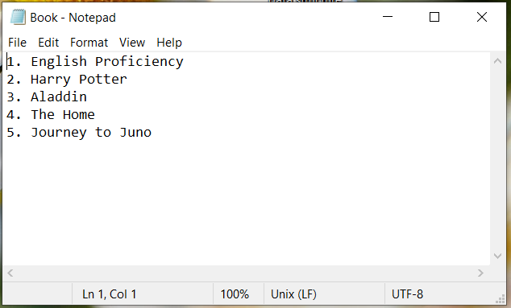

-Book number 3 changed from <<Peter Pan>> to <<Aladdin>>.

1. **Search Book**

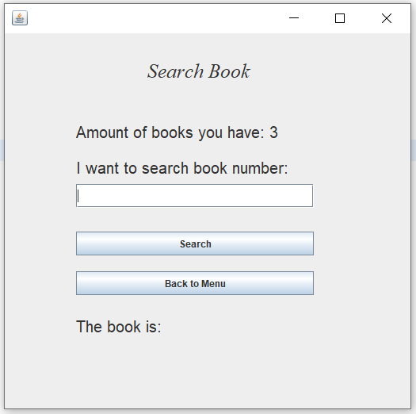

* Search Book Frame

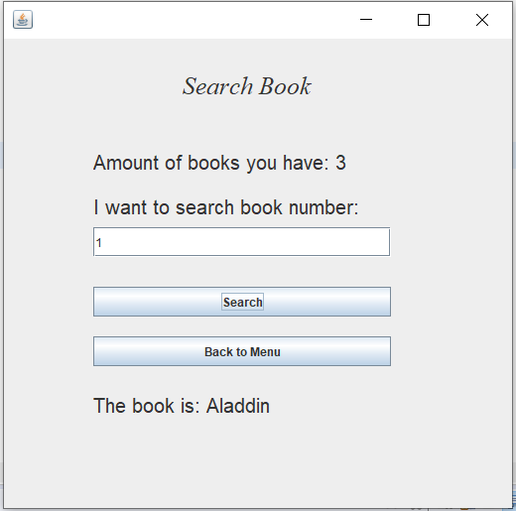

-Just enter the numerical number of book you want to search then it will tell you these number is what book.

1. **Display Book**

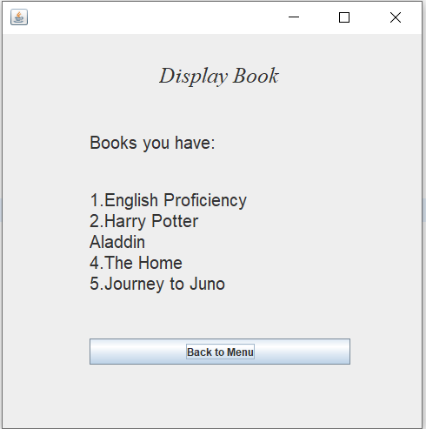

-This frame display exactly what book you have in Book.txt file. If you want to go back to main menu, just click the “Back to Menu” button.

1. **Exit**



* When we click “Exit” button, we will exit from Main Menu.

**Exception Handling for “Delete”, “Edit” and “Search” Book frame**

* We can only type numerical number in the text field, once we type alphabet, it will show error.

